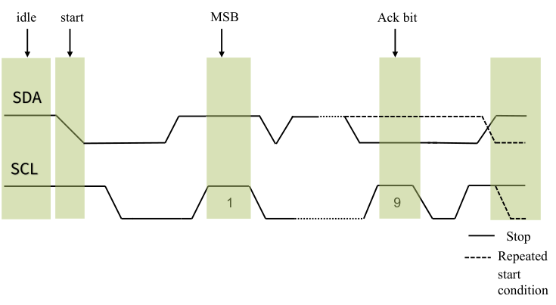

H High

L Low

L

L

H

H